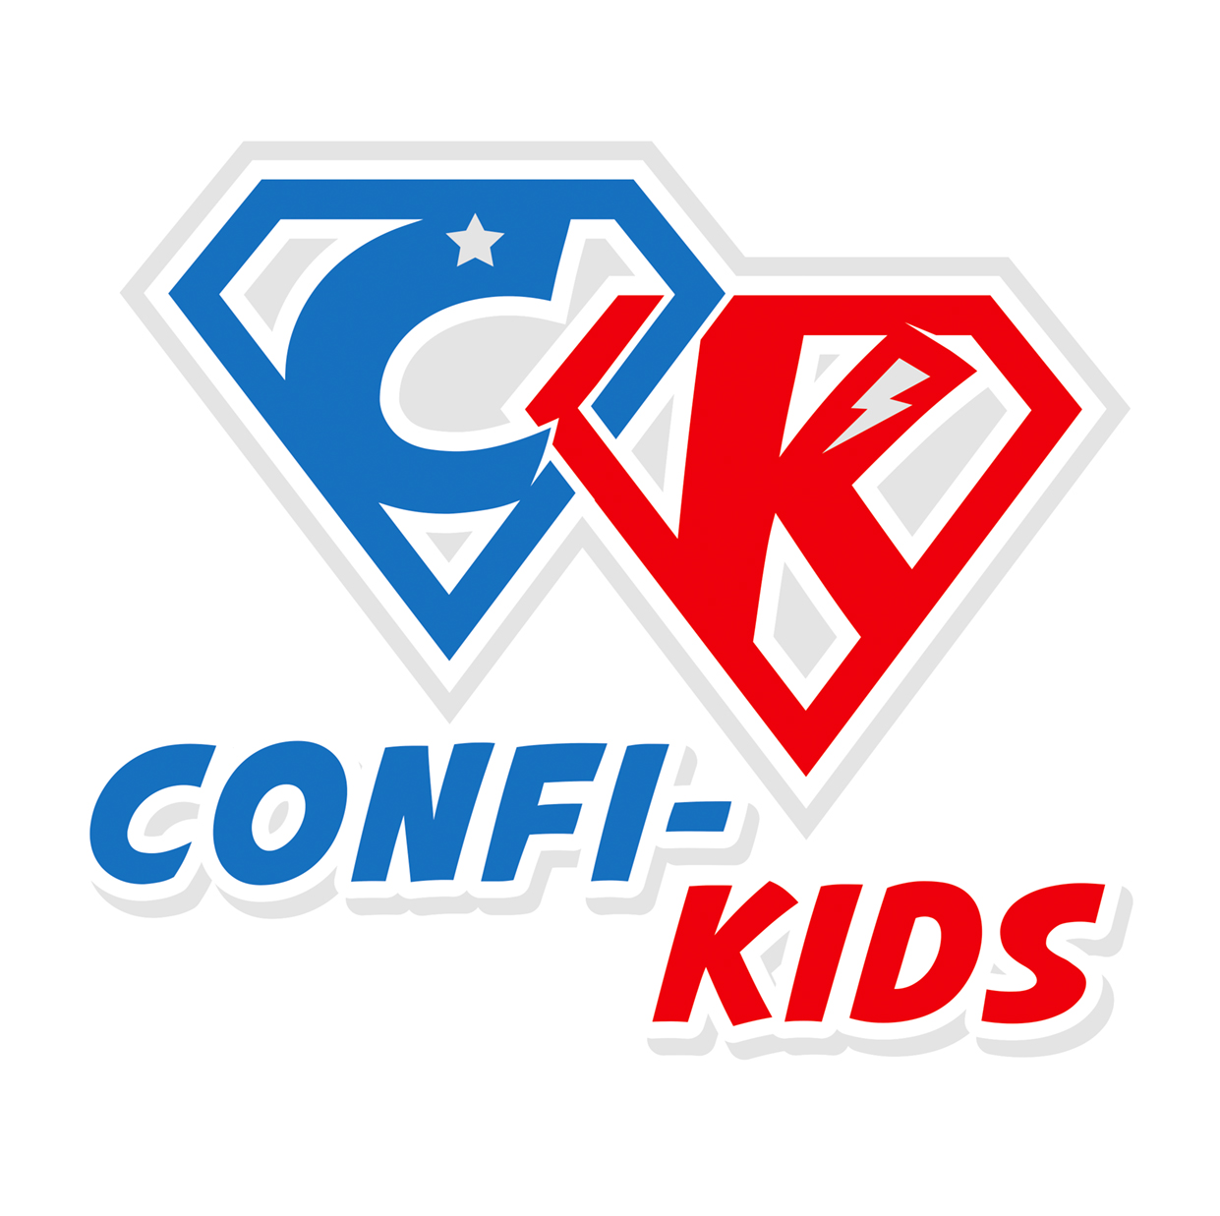
Confi-Kids

Emergency Shutdown Policy

Confi-kids UK will make every effort to keep the Club open, but in exceptional circumstances, we may need to close at short notice. This decision will not have been taken lightly and may well have been determined by an external body such as the local authority. Should this situation arise, we will make every effort to minimise the inconvenience, to staff, children and parents, and will aim to re-open as soon as is practicable.
Possible reasons for emergency shutdown of the Club include, but are not limited to:
- Serious weather conditions
- Heating system failure, burst water pipes, or loss of power supply
- Fire or bomb scare/explosion
- Death, or serious accident or illness, of a member of staff or child
- Assault on a staff member or child
- Directive by government agency (eg health authority, environment agency, security services, etc)

Should we need to evacuate the premises whilst the Club is in session, we will follow our Emergency Evacuation procedure.
Notifying parents of closure
If the Club is forced to close at short notice the Manager will use the emergency contact details we have on file to notify parents as soon as possible by phone, email, text or Social Media. To ensure that all parents receive the information, we will post a notice on the main entrance door of the Club premises. In addition, we will notify the feeder schools, and ask that they display a notice informing parents of the closure.

If the Club has been forced to close for a specific period of time, we will also inform parents of the planned date for reopening.
Session fees
There will be no refund of fees if the Club closes for a one-off short-term incident eg a snow day.

In the event of a prolonged forced closure, we must ensure that the Club remains financially viable. We have fixed costs which continue even when the club is closed. If the closure is forced by an event that is covered by our insurance, we will not charge for sessions when we are closed.

Unfortunately, not all events can be insured against, so in situations that are not covered by our insurance we will still charge full fees and refunds not offered, however we may be able to credit fees against future bookings.
Related documents
Emergency Evacuation procedure, Admissions and Fees policy

This policy was adopted by: Confi-kids UK | Date: 08/04/19 26/03/21
To be reviewed: 08/04/20 26/03/2 | Signed:C. Coulter

